Project: Mission SURE

# (SAP Upgrade, Rejuvenation & Expansion)

Financial Supply Chain Management (FSCM)

Document No: TRF-SURE-EU TRG Manual (**TRF/FSCM/1.3**) – 001 Rev. 00

**End User Training Manual**

**For**

**SAP FSCM – Asset Accounting**

Process Name: Asset Accounting

**Process No: TRF/FSCM/1.3**

# Control Copy No: TRF/FSCM/1.3

|  |  |  |  |  |  |  |
| --- | --- | --- | --- | --- | --- | --- |
| Document Change Control | | | | | | |
| Doc Version | Description | Prepared by | Date | Reviewed by | Approved by | |
| 00 | Original | Shivkumar R K | 25.12.2009 | Sanjay Thakur  Santosh Singh | |  |
|  |  |  |  |  | |  |

Introduction

Financial Supply Chain Management process in TRF has the following business processes.

|  |  |  |
| --- | --- | --- |
| Sl. No. | TRF Enterprise Process No. | Process Name |
| 1 | TRF/FSCM/1.1 | Accounts Receivable |
|  |  |  |
| 2 | TRF/FSCM/1.2 | Accounts Payable |
|  |  |  |
| 3 | TRF/FSCM/1.3 | Asset Accounting |

For each of the above processes, there are separate End User Training Manuals are available This document covers sl. No. 3. Of the above list, that is Asset accounting process.

This End User Training manual on Asset Accounts Process consists of the following sequence of sub−processes

1. Creation of Asset Number − Transaction Code: AS01
2. Create Sub Asset − Transaction Code: AS11
3. Asset Acquisition − Transaction Code: F−90
4. View Asset Values − Transaction Code: AW01N
5. Depreciation Run − Transaction Code: AFAB
6. Asset Retirement from Sale with Customer − Transaction Code: F−92
7. Asset Retirement − Without Revenue/Scrapping − Transaction Code: ABAVN
8. Transfer within Company Code − Transaction Code: ABUMN
9. Distribution of Asset − Transaction Code: AIAB
10. Settlement of Asset − Transaction Code: AIBU
11. Asset Balances (Fixed Asset Register) − Transaction Code: S_ALR_87011963

# Table of Contents

1. Purpose of AA End user Training document 4
2. Asset Accounting Process − Prerequisites 5

? Chart of Depreciation 5

? Account Determination 6

? Asset Class 6

? Depreciation Key 7

? Input − Procurement of Asset 8

? Output 9

? Depreciation on Assets 9

? Retirement of Asset 9

1. Creation of Asset Number − AS01 10
2. Create Sub Asset − AS11 17
3. Asset Acquisition − F−90 20
4. View Asset Values − AW01N 25
5. Depreciation Run − AFAB 28
6. Asset Retirement 36
7. Asset Retirement from Sale with Customer − F−92 37
8. Asset Retirement − Without Revenue/Scrapping − ABAVN 42

? Partial Retirement 45

1. Transfer within Company Code − ABUMN 46

? Partial Transfer 48

1. Asset under Construction: AIAB 49
2. Asset under Construction: AIBU 52
3. Fixed Asset Register − S_ALR_87011963 56
4. General Icons across SAP 61

1. Purpose of AA End user Training document

## This training program will focus on how SAP Accounting for Fixed Asset module manages general assets, transactions, retirements, changes and other activities. This will also include Fiscal year management, depreciation of assets.

The training program will also touch on the structures of Fixed Asset Accounting as a financial record and their significance to processes that are critical to the business accounting in the recording of accounting transactions such as revenues, adjustments, changes, depreciation and retirements/scrapping of assets and also assist in areas of internal and external reporting.

## During training program participants will be taken through the steps in the creation of the fixed asset Master records execute transactional processes in areas of: parking, posting, document changing, accounts, depreciation and document reversals, fiscal year closing and reporting.

2. Asset Accounting Process − Prerequisites



Chart of Depreciation

The chart of depreciation is a list of depreciation areas arranged according to business and legal requirements. The chart of depreciation enables you to manage all rules for the valuation of assets in a particular country or economic region. A chart of depreciation is assigned to each company code that is defined in asset accounting. SAP provides country−specific charts of depreciation with predefined depreciation areas. These charts of depreciation serve only as a reference for creating our own chart of depreciation, and are therefore not directly accessible in the SAP system. When creating a chart of depreciation, we have to copy the reference chart of depreciation from “OIN” defined for India.

Chart of depreciation: 1000

Description: Chart of Depreciation for TRF Depreciation Area’s for TRF:

|  |  |
| --- | --- |
| Depreciation Areas | Name of the Depreciation |
| 1 | Book Depreciation |
| 15 | Depreciation as per Income Tax Act 1961 |
| 20 | Cost−Accounting depreciation |



Account Determination

Account Determinations for Asset Accounting (key & depreciation). The key of an account determination must be stored in the asset class. Account Determination links an asset master record to the general ledger accounts to be posted for an accounting transaction using the asset class.

Account Determination for TRF

|  |  |
| --- | --- |
| Account Determination | Description |
| TRF100 | Buildings−Factory |
| TRF110 | Buildings−Office |
| TRF120 | Buildings−Others |
| TRF130 | Buildings−Housing Colony |
| TRF200 | Plant & Machinery − Works |
| TRF210 | Plant & Machinery − Sites |
| TRF300 | Furniture & Fittings |
| TRF400 | Office Equipments |
| TRF500 | Motor Vehicles |
| TRF510 | Bicycles |
| TRF600 | Electrical Installations |
| TRF700 | Laboratory Equipment |
| TRF800 | Technical Know−how |
| TRF900 | CWIP−Buildings Factory |
| TRF910 | CWIP−Housing Colony |
| TRF920 | CWIP−Plant & Machinery |
| TRF930 | CWIP−SAP |
| TRF940 | CWIP−Capital items in Transit |



Asset Class

The asset class is the most important criteria for structuring fixed assets from an account point of view. Every asset has to be assigned to exactly one asset class. The asset class is used to assign the assets (and their business transactions) to the correct general ledger accounts. Several asset classes can use the same account assignment. You can see that it is possible to make finer distinctions at the level of the asset class than at the level of the general ledger accounts. The most important tasks of the asset classes are:

* The assignment of default values when creating assets (particularly depreciation terms)
* The grouping of assets for reporting purposes

The following are the Asset Classes in TRF

|  |  |
| --- | --- |
| Account Determination | Description |
| TRF100 | Buildings−Factory |
| TRF110 | Buildings−Office |
| TRF120 | Buildings−Others |
| TRF130 | Buildings−Housing Colony |
| TRF200 | Plant & Machinery − Works |
| TRF210 | Plant & Machinery − Sites |
| TRF300 | Furniture & Fittings |
| TRF400 | Office Equipments |
| TRF500 | Motor Vehicles |
| TRF510 | Bicycles |
| TRF600 | Electrical Installations |
| TRF700 | Laboratory Equipment |
| TRF800 | Technical Know−how |
| TRF950 | CWIP−Buildings Factory |
| TRF960 | CWIP−Plant & Machinery |
| TRF970 | CWIP−Electrical Installations |



Depreciation Key

Depreciation keys contain the calculation methods for depreciation calculation and parameters that control:

* Ordinary depreciation
* Special depreciation
* Scrap Value (Cut−off Value)

You can enter a separate depreciation key for each depreciation area in the asset master record. The following are the Book Depreciation Keys for TRF as per Company’s act 1956 and Straight Line Method (SLM) to be used:

|  |  |
| --- | --- |
| Depreciation Key | Description |
| TR00 | 0% Depreciation |
| TR01 | 1.63% Buildings Residence (Office, Housing colony and Others) |
| TR02 | 3.34% Buildings−Factories |
| TR03 | 4.75% Plant & Machinery − Single Shift |
| TR04 | 7.42% Plant & Machinery − Double Shift |
| TR05 | 10.34% Plant & Machinery − Triple Shift |
| TR06 | 13.91% Plant & Machinery − General Rate of Depreciation |
| TR07 | 7.07% Plant & Machinery − Special Rate |
| TR08 | 11.31% Plant & Machinery − (Moulds iron, Shoes and leather  good fabric) |
| TR09 | 100% on Plant & Machinery − Works |
| TR10 | 7.07% Bicycle |
| TR11 | 9.50% Motor Car (Vehicle) |
| TR12 | 16.21% Computer − Hardware |
| TR13 | 6.33% Furniture & Fittings − General |
| TR14 | 100% on Furniture & Fittings (on need basis) |
| TR15 | 16.67% on Technical Know−How |
| TR16 | 20% on Computer Software |
| TR17 | 100% on Office Equipment |

The following are the TAX DEPRECIATION keys along with Rates for TRF as per Income Tax Act 1961 and WRITTEN DOWN VALUES (WDV) to be used:

|  |  |
| --- | --- |
| Depreciation Key | Description |
| TR50 | 5% Used for Residential Purpose |
| TR51 | 10% Used − Not for residential purpose |
| TR52 | 10% Furniture & Fixtures |
| TR53 | 30% Plant & Machinery |
| TR54 | 15% Office Equipment |
| TR55 | 15% Electric Installation |
| TR56 | 15% Motor Vehicle |
| TR57 | 60% Computer (Hardware) |
| TR58 | 25% Technical Know How |
| TR59 | 60% Computer (Software) |

Where any assets acquired by the assesses during the previous year and put to use for the purpose of business for a period of less than 180 days in that previous year, then value will be half for calculating depreciation



Input − Procurement of Asset

The Central Procurement Cell (CPC) will get the budge approval from the board under three categories:

* Major Capital Scheme
* MD’s Sanction Limit

Miscellaneous capital scheme−ceiling of each scheme Minor Capital scheme−ceiling of scheme

CPC will send a request for an asset number to accounts



Output

* Accounts will give asset number as per the nature of asset. If the asset is not “ready to use asset” then the asset number should be assigned to Asset under Construction (AuC) Asset class. If it is ready to use asset it will go to respective asset class.
* After getting the asset number the procuring (user) department will prepare a Purchase Requisition
* The CPC will release purchase order (PO) on the basis of PR received



Depreciation on Assets

* Asset will be depreciated at SLM for Financial Statements, at the rates prescribed in the Company’s Act 1956
* Assets will be depreciated at DWV method to be followed at the rates prescribed in the Income Tax Act 1956
* Depreciation to be calculated on monthly basis
* Depreciation charged on the asset shall be credited to depreciation reserve account. Depreciation reserve account will be common for the entire asset except Technical Know How, for which separate depreciation reserve account to be created
* For assets valuing less than Rs5000/− and mobile phones (Low Value Assets) should be 100% depreciated in the same year



Retirement of Asset

The Asset Retirement will be of two types:

1. Retirement with sale value is normally sale of asset to a customer. The profit or loss on the retirement should go to the respective GL
2. Retirement without sale value, at a certain interval each class of assets shall be physically verified and shortages if any to be scrapped and written−off. The loss, if any should go to the respective GL

3. Creation of Asset Number − AS01

If you acquire a new fixed asset for the business which has no master data existing in the system, you need to create the master data for the asset in the system before you can create any transactions against this asset. Action by an Authorized trained staff only.

* 1. Access the transaction choosing one of the following navigation options:

|  |  |
| --- | --- |
| SAP ECC menu | Accounting  Financial Accounting  Fixed Assets  Asset  Create   AS01 − Asset |
| Transaction code | AS01 |

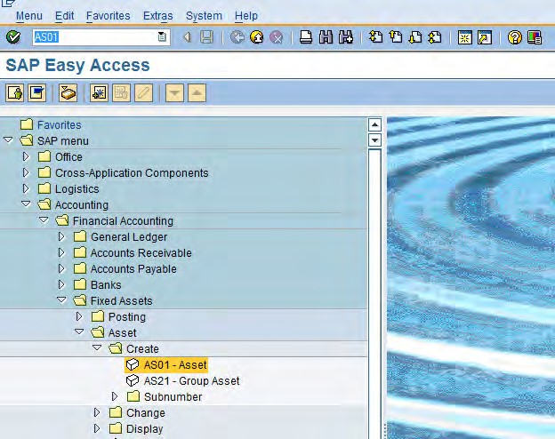

Enter the transaction code AS01 in command text field

OR

Follow the path to create asset

Note: The screen curser will default into the Asset class:

* 1. Specify at least an Asset class or select a name for the asset from the icon button as shown in the screen shot below

|  |  |  |  |
| --- | --- | --- | --- |
| Field Name | Description | R/O/C | Values |
| Asset class | Classification of the asset | R | Use drill−down to locate the asset class |
| Company code | Enter your Company Code | R | 1000 |
| Number of similar assets | Number of similar assets that you want to create in the system when you save. | O | This function enables you to create multiple similar assets in one master transaction.  These assets initially only differ in their asset numbers. When you save, you can also enter a description and inventory number for each  individual record. |
| Reference: Asset Sub−number Company  code | The reference asset that you are copying from | O | Check the data before you copy |

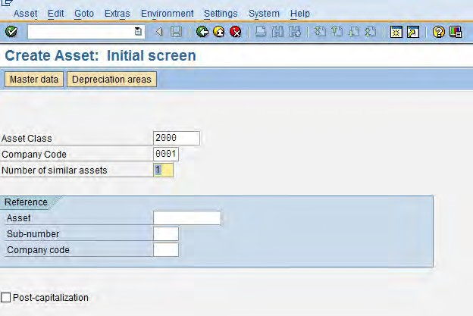

Curser will default to this field

* 1. <Enter> or if click on the icon  you will be asked to save, click on the next tab
  2. Create Asset: Master Data− General Tab highlighted in dark blue on screen ().
  3. Process of creation and field names and prompts are as follows, on screen “Create Asset: Master Data”, enter information in the fields as specified in the table below:

|  |  |  |  |
| --- | --- | --- | --- |
| Field Name | Description | R/O/C | Values |
| Description | The description of the asset | R | Example: Pulley |
| Asset main no  text | One line description of the asset. It will  appear in reporting. | O | If leave blank, the first line of description  will be copied over to this field. |
| Manage Historically | Set this indicator if you want this asset to be manage Historically | O | This indicator ensures that this asset is manage Historically |
| Inventory no | You can enter an inventory number for the asset. The inventory is placed into the standard inventory list for Asset Accounting  (Information System). | O | Accounting trace for reporting within the Financial Accounting Information System |
| Quantity | Quantity of the assets to be acquired and  the unit of measurement | O | Example: 10 and “3 |
| Inventory and Posting Information | | | |
| Inventory note | Supplementary information for the  analysis of physical inventory | O | General Information for Users |
| Last inventory  on | You can enter the date of the last  inventory. | O | This field is for information only |
| Include assets in inventory list | Set this indicator if you want this asset to be counted in a physical inventory check | O | This indicator ensures that this asset is included in the standard inventory list of Asset Accounting. Asset without this  indicator are not output by the report. |
| Posting  Information | When the document was posted |  | Used for information when and why and  who posted the document |
| Capitalized on | The capitalization date is the value  date of an asset |  | The field will be automatically updated  upon acquisition posting. |
| First acquisition  On | The system automatically sets the asset value date of the first acquisition posting in  this field |  | The field will be automatically updated upon acquisition posting |
| Acquisition  year | The system enters the fiscal year of the first  acquisition posting in this field |  | The field will be automatically updated  upon acquisition posting |
| Deactivation on | The system enters the asset value date of the retirement posting for a full retirement in this field | O | Once an asset has been deactivated, you can no longer post to the asset (with one exception: posting a reversal of the last retirement). In order for you to be able to make correction postings after an asset has been deactivated, you can also manually change the deactivation date in  the asset master record |

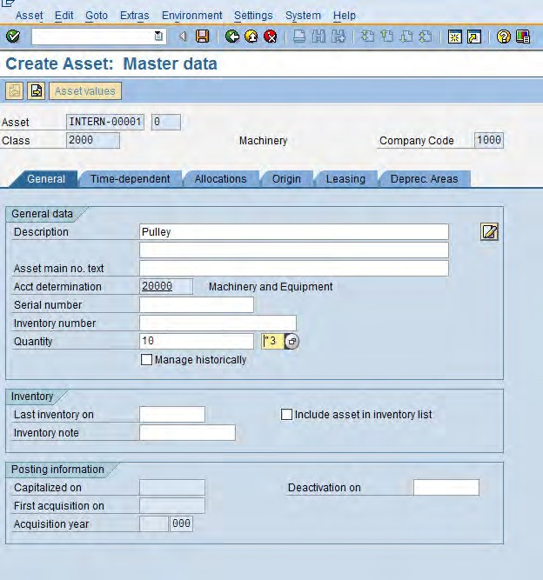

* 1. Once you have entered the required data in the fields, if you click on then, you will be asked to save the data− Click on the time Dependent tab on screen.

|  |  |  |  |
| --- | --- | --- | --- |
| Field Name | Description | R/O/C | Values |
| Business area | This field must be left blank as the business area  will be default through cost centre | R | Example: 0001 |
| Cost centre | This is the cost centre where the depreciation  expenses of the asset will be charged | R | Use drill−down to locate  the cost centre |
| Plant | Used in selection criteria in reporting | O | Not displayed |
| Location | Used in selection criteria in reporting | O | Use drill−down to find out  the predefined location. |
| Serial no. |  | O | This is an optional (but  not for this update) |

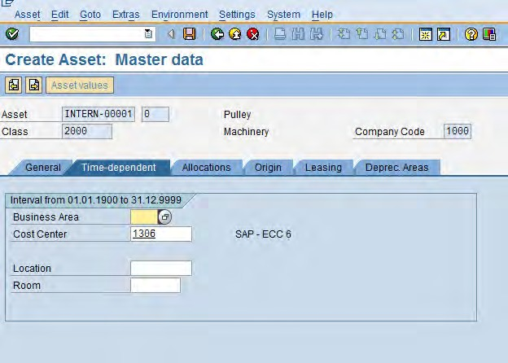

* 1. Click on the Origin tab and update the fields as required

|  |  |  |  |
| --- | --- | --- | --- |
| Field Name | Description | R/O/C | Values |
| Vendor | You can enter vendor number  (Customer) | O | This field is for information  only |
| Asset Purchased  New | Set this indicator if the asset was purchased new (not used) | O | This field is for information only |
| Purchased  Used | Set this indicator, if this asset was second−hand  when it was acquired (not new). | O | This field is for information  only |

* 1. Enter the date in the other fields

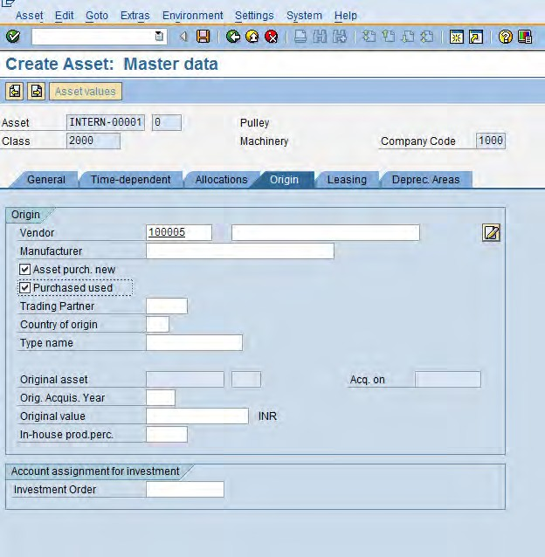

* 1. Click on the Depreciation Area tab

You will be prompted with the following screen: (Valuation information displayed for asset).

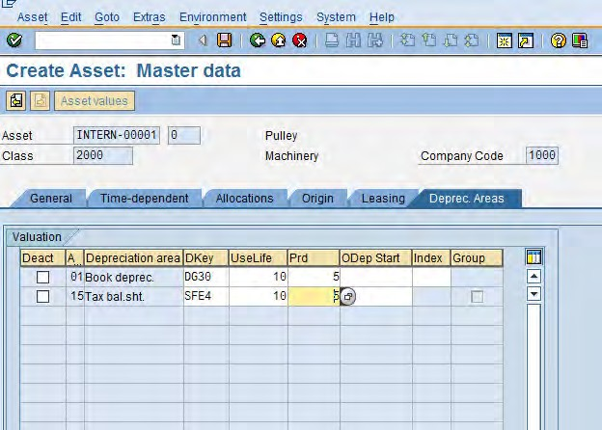

The time period over which the asset is to be used and depreciated

* 1. Click on the icon to save the asset. The system will assign Asset number. Then the following screen will be displayed
  2. The system will display the number of the document generated by this Invoice, record this below.



* 1. Click on the Exit button or press Shift+F3 to return to the SAP Easy Access screen.

End of document - of T-code AS01

4. Create Sub Asset − AS11

A sub−asset class is a collection of assets that have common characteristics within both the asset class and the sub−asset class. The sub−asset class also has attributes that make it different than the parent group of assets

1. Access the transaction choosing one of the following navigation options:

|  |  |
| --- | --- |
| SAP R/3 menu | Accounting🡪Financial accounting🡪Fixed assets 🡪 Create🡪Sub  number🡪AS11 - Asset |
| Transaction code | AS11 |

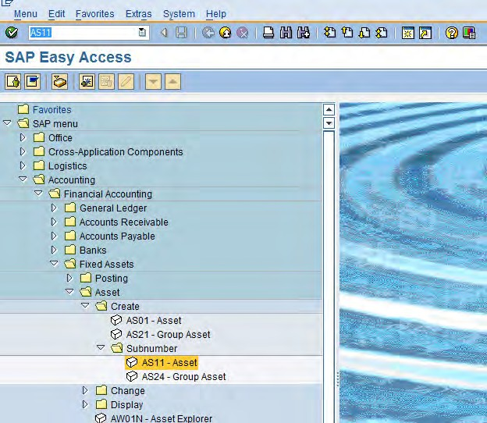

Enter the transaction code FS11 in command text field

OR

Follow the path to create sub asset

1. Enter the following details

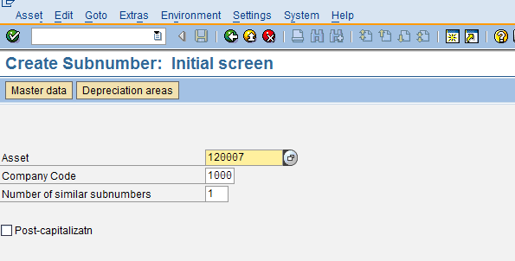

Enter 6 digit asset numbers

1. Name of the asset and other details for asset master will come automiatically from the main asset master. If you want to change the name of asset master, It can be done here

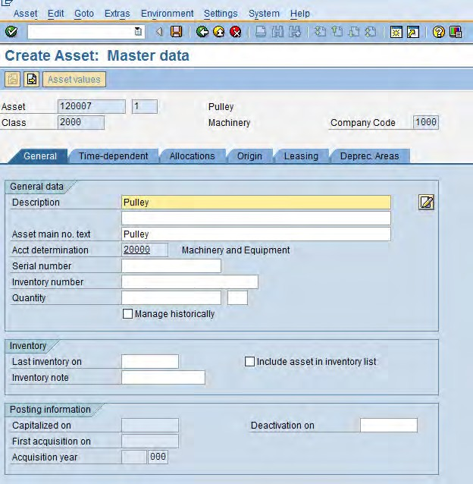

1. Go to Depreciation area tab and fill the Depreciation start date following screen will appear.

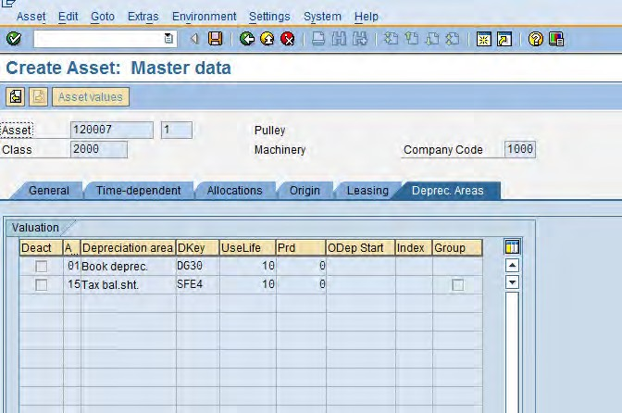

1. Click on the icon to save the asset. The system will assign Asset number. Then the following screen will be displayed
2. The system will display the number of the document generated by this Invoice, record this below.



Note: A Sub asset has been created with the above shown number

1. Click on the Exit  button or press Shift+F3 to return to the SAP Easy Access screen.

End of document - of T-code AS11

5. Asset Acquisition − F−90

Acquisition of fixed assets, there are four different types of asset acquisition:

* Purchase acquisition
* Acquisition from in−house production
* Subsequent acquisition to an already capitalized asset
* Post−capitalization (in a period after that of the actual acquisition)

1. Access the transaction choosing one of the following navigation options:

|  |  |
| --- | --- |
| SAP R/3 menu | Accounting C Financial AccountingC Fixed assetsC Posting  CAcquisitionC External AcquisitionCF-90 with Vendor |
| Transaction code | F-90 |

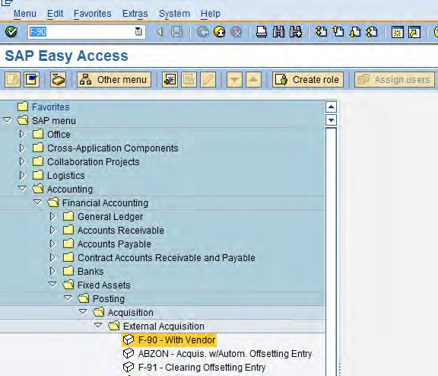

Enter the transaction code F−90 in command text field

OR

Follow the path to Acquire Asset from purchase

1. On screen “Acquisition from purchase with Vendor Screen”, enter information in the fields as specified in the table below: Page 43 displayed the table information

|  |  |  |  |
| --- | --- | --- | --- |
| Field Name | Description | R/O/C | Values |
| Header Information | | | |
| Doc. date | Source document date. | R | Example: 21.12.2009 |
| Document Type | The default document type for this screen is  KR. Do not Change it | R | Example: KR |
| Company Code | Enter your Company Code | R | Example: 1000 |
| Posting Date | Date for posting a document to financial accounting. This will determine which fiscal period (also known as posting period) the transaction is recognized | R | Example: 21.12.2009 |
| Reference | One of the key fields that can be used to search for documents at a later retrieval date. Any user−defined  text. | R | Example: Asset Purchase |
| Line Item Information | | | |
| Posting Key | Posting keys represent Debit or Credit entry of any  account type | R | Example: 31 |
| Account | Enter the Vendor account Number | R | Example: 100085 |

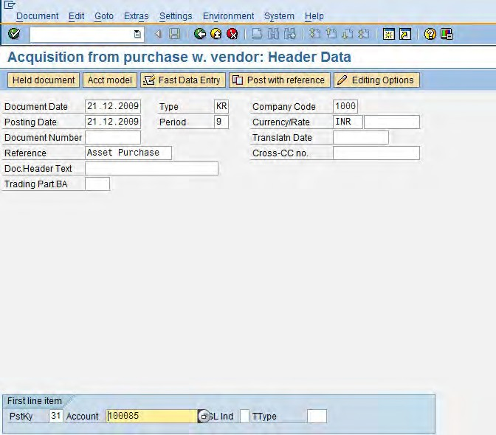

1. Press <Enter> or click on the icon , you will be prompted with the following screen

|  |  |  |  |
| --- | --- | --- | --- |
| Field Name | Description | R/O/C | Values |
| Amount |  | R | Example: 25252525 |
| Text |  | O | Example: Asset  Purchse |
| Posting Key | Enter the posting Key to debit Asset | R | Example: 70 |
| Account | Enter Asset Number | R | Example: 200001−0  (Laptop) |
| Transaction Type | The transaction Type in Asset Accounting classifies the business transaction. The transaction type controls various system  activities when business transactions are posted. | R | Example: 100 |

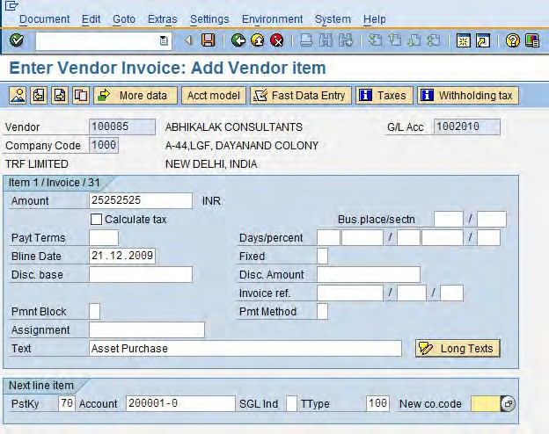

1. You can check your document before postings. Select Document C Simulate or click on  button or press Enter

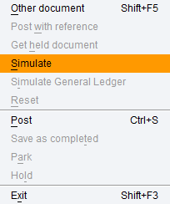

1. The following WTH tax screen will be displayed, select the appropriate W/Tax code and press enter

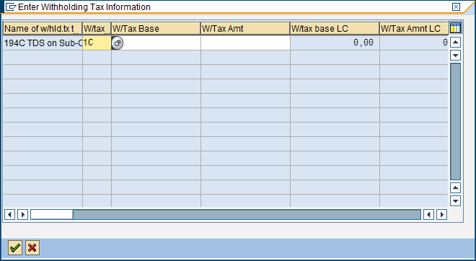

1. Click the Enter  button

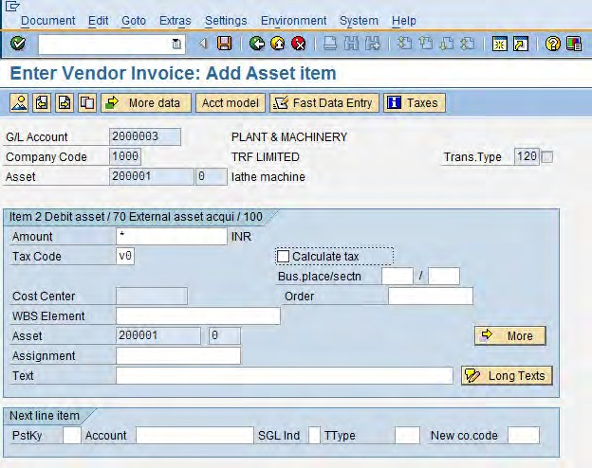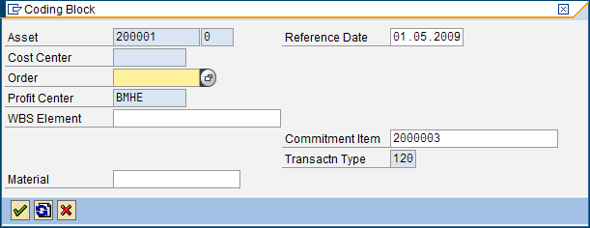

Enter * or the asset amount

in the amount text field

Enter the appropriate tax code as

per TRF and statutory requirement.

Click on the more button, in

the Coding block pop up window, verify the Profit centre and other details and press enter

1. In the following document overview screen, verify the details

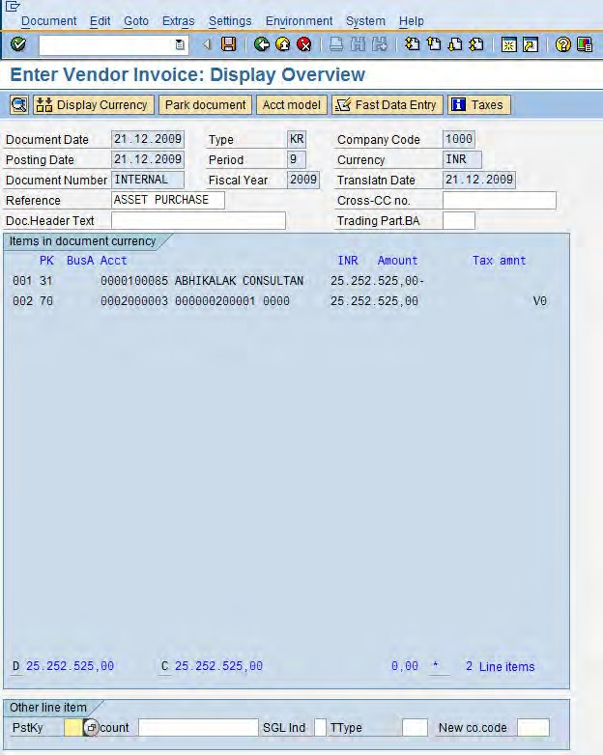

1. To post your entries, click the Save button.
2. The message bar displays: “Document 1909000037 was posted in company code 1000” − record this number below.



1. Click on the Exit button or press Shift+F3 to return to the SAP Easy Access screen.

End of document – of T-code F-90

6. View Asset Values − AW01N

This screen provides Information, data and images solely for reference purposes

1. Access the transaction choosing one of the following navigation options:

|  |  |
| --- | --- |
| SAP R/3 menu | Accounting C Financial Accounting C Fixed Assets 🡪 Asset 🡪 AW01N –  Asset Explorer |
| Transaction code | AW01N |

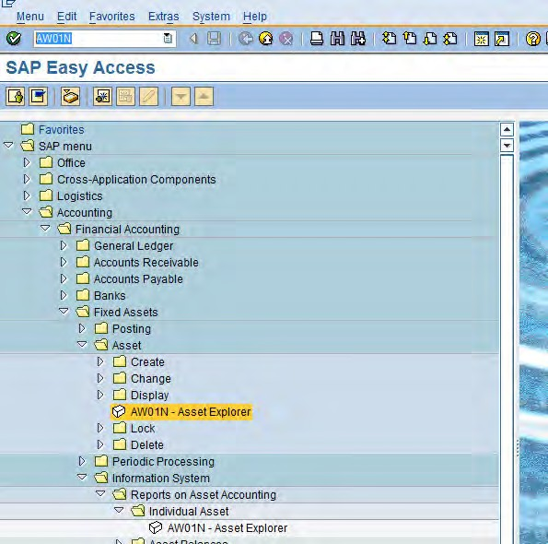

Enter the transaction code AW01N in command text field

OR

Follow the path to explore Asset information

1. Update the required and optional fields and Click the Enter button

|  |  |  |
| --- | --- | --- |
| Field Name | Description | Values |
| Company code | Number of the company code that the Customer belongs to | Example: 1000 |
| Asset Asset number for which you would like to see the  information | | Example: 200006 |

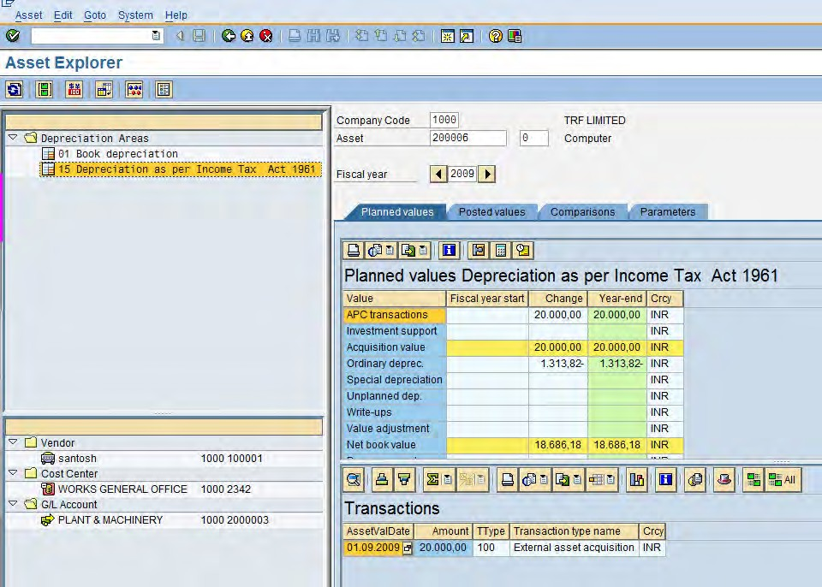

1. If the areas are defined, then the above screen is displayed or the below screen (refer Figure 1) is displayed, Verify the required information and exit the screen
2. The following screen will be displayed if there are no areas defined for the asset

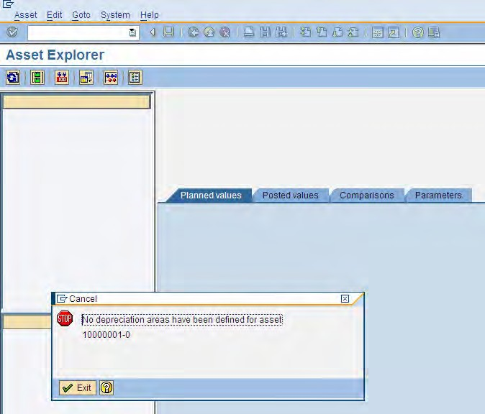

**Figure 1**

1. Click on the Exit  button or press Shift+F3 to return to the SAP Easy Access screen.

End of document – of T-code AW01N

7. Depreciation Run − AFAB

A posting to a fixed asset initially causes the planned depreciation to change in Asset Accounting. The accumulated depreciation accounts and depreciation accounts of the balance sheet and profit and loss statement are not updated immediately, however. The total planned depreciation is not posted to Financial Accounting (only collective documents are created) until the periodic depreciation posting run is executed.

The depreciation posting should be run periodically (annually, semi−annually, quarterly, or monthly). When executed as an update run, the program has to be started in the background.

The system creates posting documents for each depreciation area and account group in accordance with the posting cycles specified in Customizing. As the posting date, the system uses

* The last day of the period for normal periods (no special periods)
* The last day of the fiscal year for special periods

When depreciation is configured in SAP the user will do a depreciation run every month to calculate the depreciation and the depreciation value is deducted from asset. The asset depreciation run will generate an accounting transaction to lower the value of assets as maintained in the asset account and charge that to an asset depreciation account − en expense. Even though no cash flow is involved, this transaction lowers the profit (incur loss) of the business. To action depreciation run use transaction code

1. Access the transaction choosing one of the following navigation options:

|  |  |
| --- | --- |
| SAP R/3 menu | Accounting C Financial Accounting C Periodic Processing C  Depreciation run |
| Transaction code | AFAB |

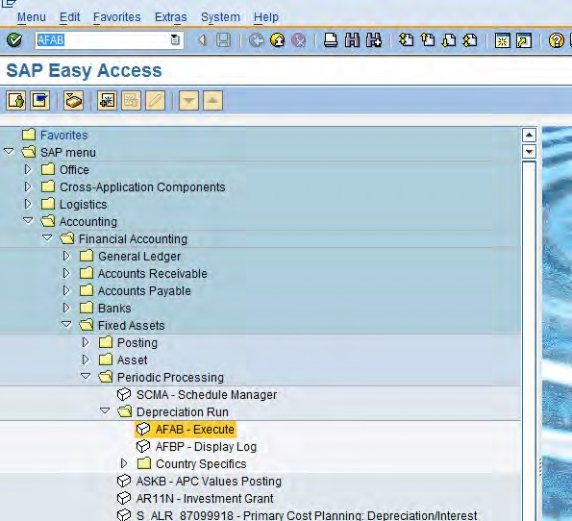

Enter the transaction code AFAB in command text field

OR

Follow the path for Depreciation Run

Note: It is recommended that you activate “Test Run” and “Error Analysis” first before executing final run. This is a very helpful to initially identify and diagnose possible errors during depreciation posting run. As stated above, this transaction is only executed through background processing and logs for errors won’t be displayed.

1. On screen “Depreciation Posting Run Screen”, enter information in the fields as specified in the table below

|  |  |  |  |
| --- | --- | --- | --- |
| Field Name | Description | R/O/C | Values |
| Company  Code | Enter your Company Code | R | Example: 1000 |
| Fiscal Year | Enter the fiscal year of the depreciation | R | Example: 2009 |
| Period | Enter the period for the depreciation run | R | Example: 9 |
| Reason for posting run | 1. Planned Posting run: Mark this indicator on if the depreciation run is executed first time for the period 2. Repeat Run: Mark the indicator on if repeat run to be executed | R | Example: |
| Test Run | If this check box is selected the program will run in TEST MODE.  Make sure to mark the indicator on before actual run | R | Example: |

The system determines the next posting period to be posted in, according to the defined depreciation posting frequency (i.e. mthly, quarterly, yearly)

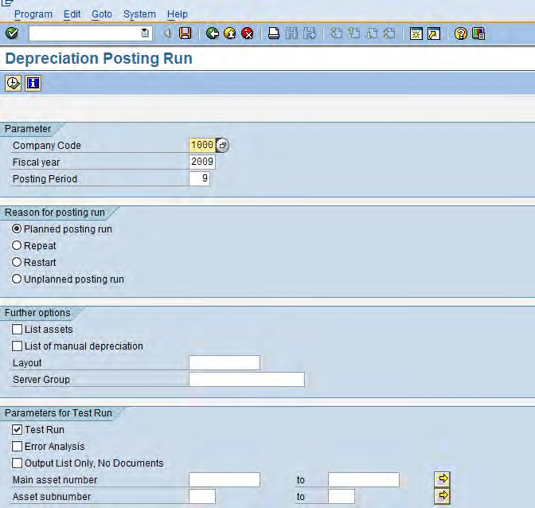

The system determines the

next posting period to be posted in, according to the defined depreciation posting frequency (i.e. mthly, quarterly, yearly)

Depreciation posting is performed in several steps

and at each step the system logs the current status. If a program is terminated during a posting run, then the program has to be started again in restart mode to clear the data base of possible inconsistencies. This should be selected only in SELECTED CASES

It is possible to repeat the posting run within the

period last posted. The repeat run can be restricted to specific assets, the system posts changes to depreciation as compared to depreciation amounts from the previous run.





Note: To display the possible error messages, Select Go to C Error Log. If depreciation posting run contain errors, a pop−up screen with message”Document lines: Display messages” appears. Otherwise, a message “No errors” will be displayed. Below is a screen shot of an error message:

Click on the message to display the analysis of the error. Once error resolved, you may retry executing Test Run until message “No errors” appears. Then execute a Final Run of your depreciation posting run through background processing

1. Press F8 or click on Execute button
2. If the following message is displayed, Press yes to continue

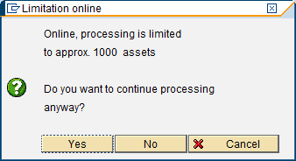

1. You will be prompted with the following screen

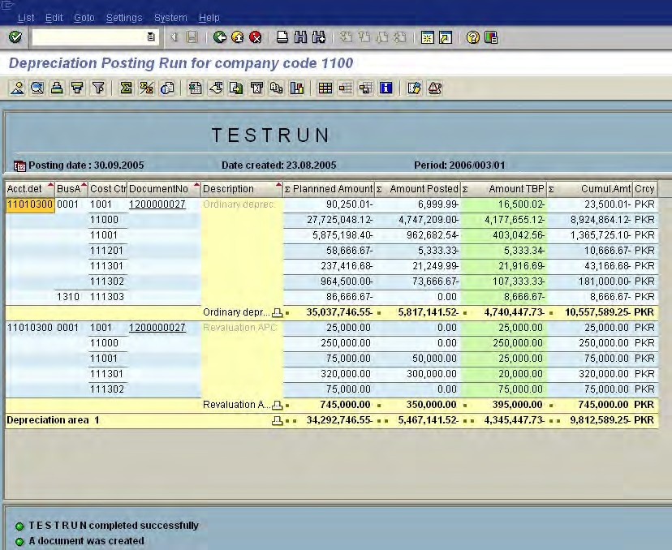

Test run completed successes fully.

Press F3 or Back button (green arrow)

Note: Remove parameters on Test Run − Remember before running the actual remove the indicator in the Test Run box.



Note: As there was no data available, the above screen has been copied from outside TRF for reference purpose

1. On screen “Depreciation Posting Run Screen”, enter information in the fields as specified in the table below

|  |  |  |  |
| --- | --- | --- | --- |
| Field Name | Description | R/O/C | Values |
| Company  Code | Enter your Company Code | R | Example: 1000 |
| Fiscal Year | Enter the fiscal year of the depreciation | R | Example: 2009 |
| Period | Enter the period for the depreciation run | R | Example: 9 |
| Reason for posting run | Repeat Run: Mark the indicator on if repeat run to be executed | R | Example: |
| Test Run | If this check box is selected the program will run in TEST MODE.  Make sure to mark the indicator on before actual run | R | Example: |



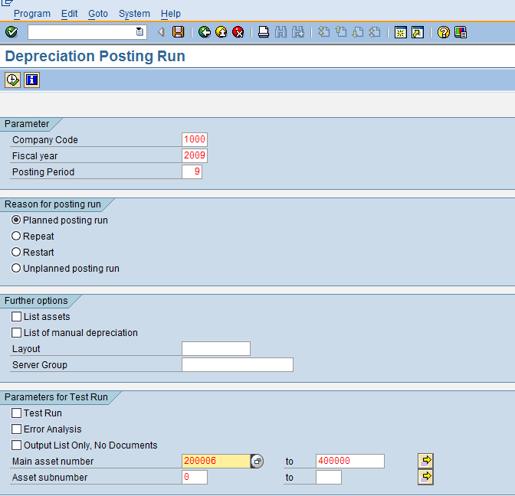

Note: Please select the required printer based on per permissions or location of local printer

1. To execute, Go to program −> Execute in Background or press F9

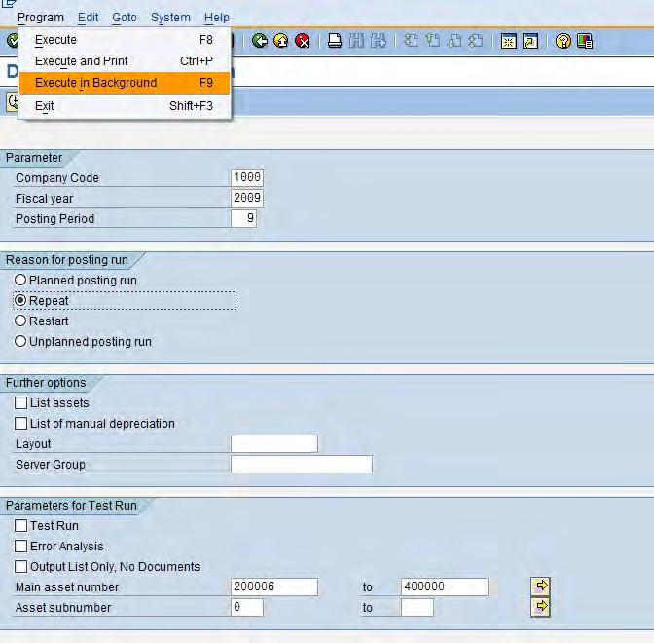

1. You will be prompted with the Print Parameters pop up window, enter the printer name and select other options according and press Enter 

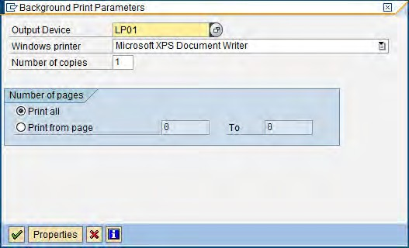



1. You will be prompted with the Start Time pop up window

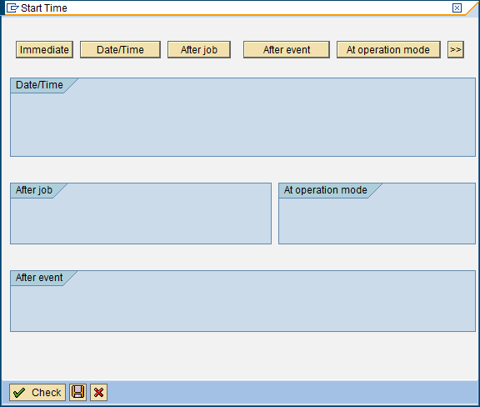

Press Immediate

Press Save

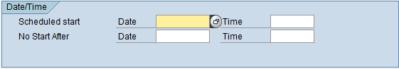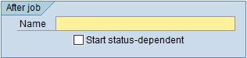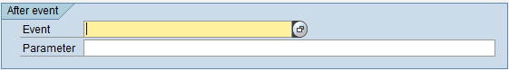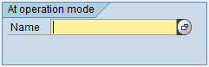

Note: Below options can be selected and details updated per need basis, these fields can be skipped

1. Depreciation run steps are clear− Press immediate, and then save
2. Following message will be displayed in the status bar



1. As soon as the job is finished an account will be generated in the system
2. Next go to System−>Services−>Jobs−>Job overview, to check if the job is ready

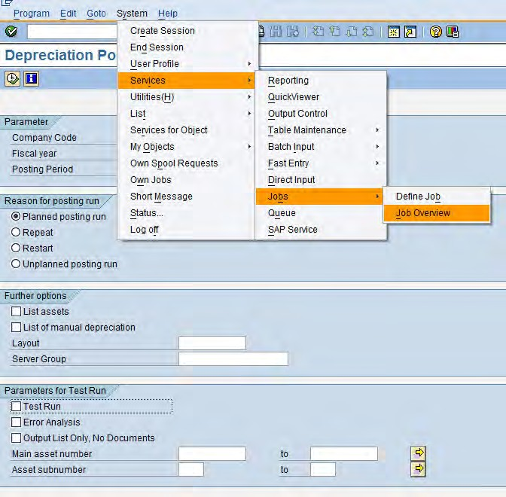

1. Choose Execute button

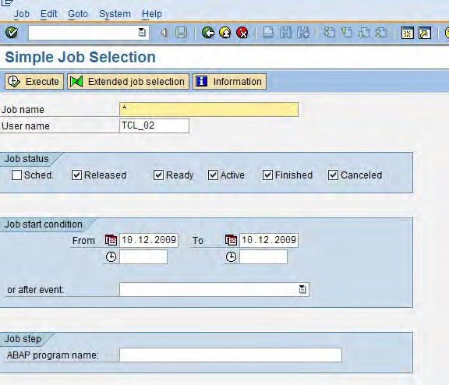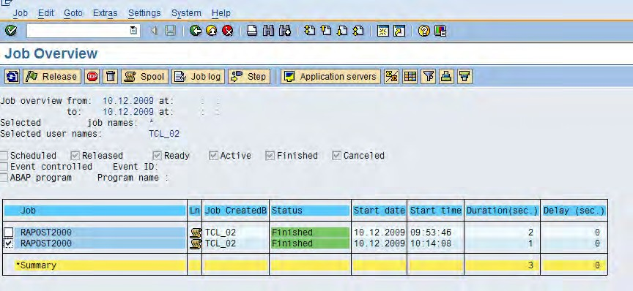

You see an overview of the jobs to be run today under your name. Only when your job has the status Finished you can execute the postings

1. You see an overview of the jobs to be run under your name. Only when your job has the status

Finished you can execute the postings

1. To change the status at any time, choose Refresh button



1. Click on the Exit  button or press Shift+F3 to return to the SAP Easy Access screen.

End of document – of T-code AFAB

8. Asset Retirement



Scrapping

Sale

Retirement

Without Customer

With Customer

Asset Sale with Customer

The system enables you to post the entry to Accounts Receivable, the revenue posting and the asset retirement in one step. In this posting transaction, you must first post the revenue (debit A/R, credit revenue from asset sale), and then post the asset retirement. An indicator in the posting transaction specifies that the system posts the asset retirement after the revenue posting.

The prerequisite for this is that the sales revenue account in Financial Accounting, to which the revenue should be posted, has a field status variant in its master data in which the "Asset retirement" field (category Asset Accounting) is defined as a required or optional entry field.

Retirement without Revenue

A retirement without revenue is the removal of an asset from the asset portfolio without any revenue, for example, by scrapping. When you use this posting option, the system does not create revenue and profit and loss postings. Instead it creates the posting "loss from an asset retirement without revenue" in the amount of the net book value being retired.

9. Asset Retirement from Sale with Customer − F−92

Asset retirement is the removal of an asset or part of an asset from the asset portfolio. This removal of an asset (or part of an asset) is posted from a bookkeeping perspective as an asset retirement. Depending on the organizational considerations, or the business transaction which leads to the retirement, you can distinguish the following types of retirement:

* An asset is sold, resulting in revenue being earned. The sale is posted with a customer.
* An asset is sold, resulting in revenue being earned. The sale is posted against a clearing account.
* An asset has to be scrapped, with no revenue earned.
* An asset is sold to an affiliated company

1. Access the transaction choosing one of the following navigation options:

|  |  |
| --- | --- |
| SAP R/3 menu | Accounting C Financial Accounting C Fixed Assets C Posting 🡪  Retirement🡪 Retirement w/Revenue 🡪 F-92 – With Customer |
| Transaction code | F-92 |

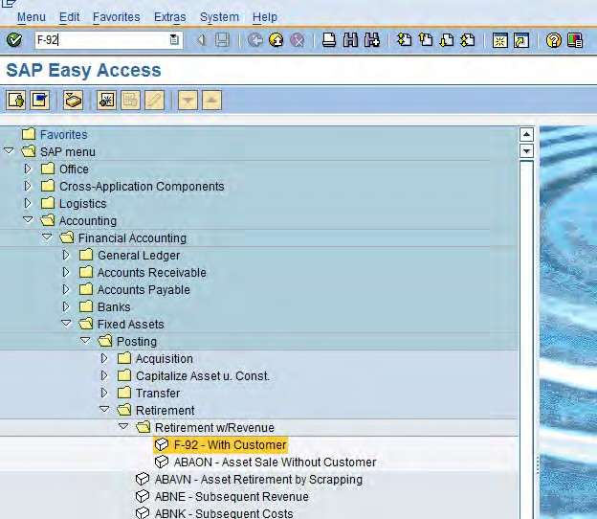

Enter the transaction code F−92 in command text field

OR

Follow the path to Retire Asset with revenue

1. Update the information in the fields as specified in the table below

|  |  |  |  |
| --- | --- | --- | --- |
| Field Name | Description | R/O/C | Values |
| Header Information | | | |
| Document date | Source document date | R | Example: Any date |
| Document Type | The default document type for this screen is  DR. Do not Change it | R | Example: DR |
| Company Code | Company Code | R | Example: 1000 |
| Posting Date | Date for posting a document to financial accounting. This will determine which fiscal period (also known as  posting period) the transaction is recognized | R | Example: Any Date |
| Reference | One of the key fields that can be used to search for documents at a later retrieval date. Any user−defined  text | R | Example: Asst Retrmnt |
| Line Item information | | | |
| Posting Key | Posting keys represent Debit or Credit entry of any  account type (debit customer invoice) | R | Example: 01 |
| Account | Enter the Customer account Number | R | Example: 100030 |

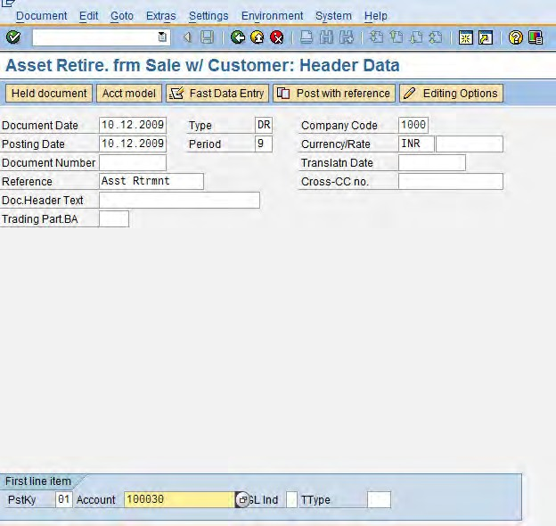

1. Click the Enter  button, the system will take you to the below screen
2. Update the required and optional fields by capturing the necessary data

|  |  |  |  |
| --- | --- | --- | --- |
| Field Name | Description | R/O/C | Values |
| Amount | Enter the asset value amount | R | Example: 4555000 |
| Posting Key | Enter Posting Key 50 to credit G/L Account | R | Example: 50 |
| Account | Enter G/L Account Number (clearing account or  Revenue Account) | R | Example: 1001002 |

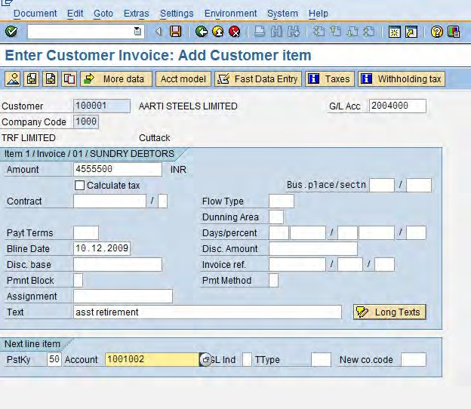

1. Click the Enter  button, the system will take the user to the below screen, Update the required

and optional fields by capturing the necessary data

|  |  |  |  |
| --- | --- | --- | --- |
| Field Name | Description | R/O/C | Values |
| Amount | Enter the asset value amount or “ * “ | R | Example: 4555000 or  “ * “ |
| Profit Center | Enter the profit Center | R | Example: BMHE |

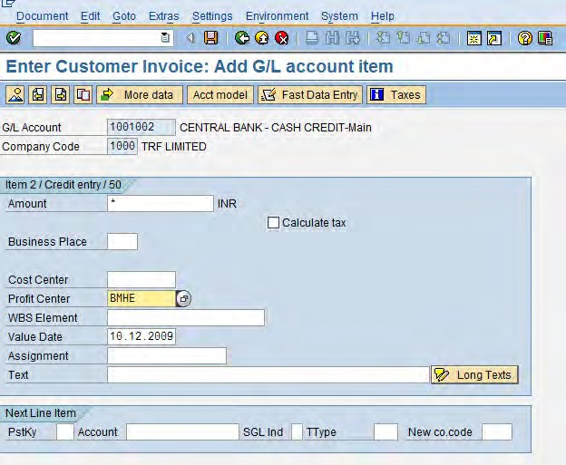

1. You can check your document before postings. Select Document C Simulate.



1. Verify the details and to post your entries, click the Save button

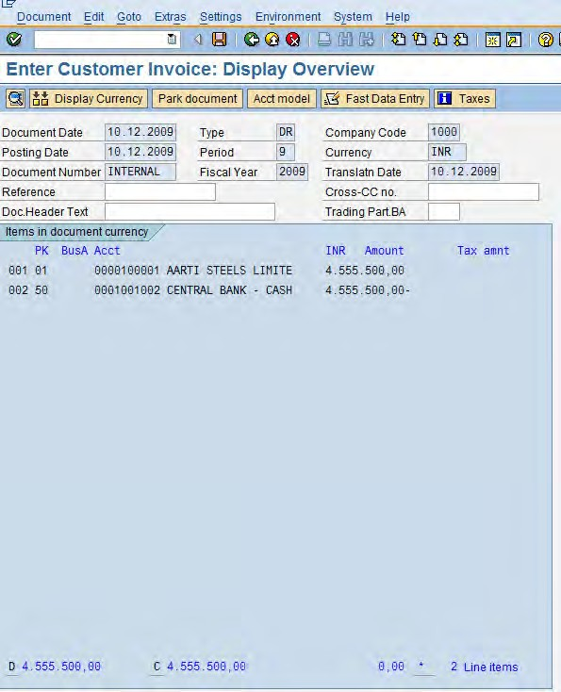

1. The message bar displays: “Document 1409000015 was posted in company code 1000” − record this number below.



1. Click on the Exit button or press Shift+F3 to return to the SAP Easy Access screen.

End of document – of T-code F-92

10. Asset Retirement − Without Revenue/Scrapping − ABAVN

Retirement without revenue is a removal of an asset from the asset portfolio without any revenue, for example, by scrapping. When you use this posting option, the system does not create revenue and gain/loss postings. Instead it creates a loss from an asset retirement without revenue posting in the amount of the net book value being retired.

When an asset is retired without revenue, the system generates a loss for asset retirement without revenue

equal to the retired net book value instead of the revenue and gain/loss posting.

1. Access the transaction choosing one of the following navigation options:

|  |  |
| --- | --- |
| SAP R/3 menu | Accounting C Financial Accounting C Fixed assets C PostingC  Retirement C Asset Retirement by Scrapping Asset |
| Transaction code | ABAVN |

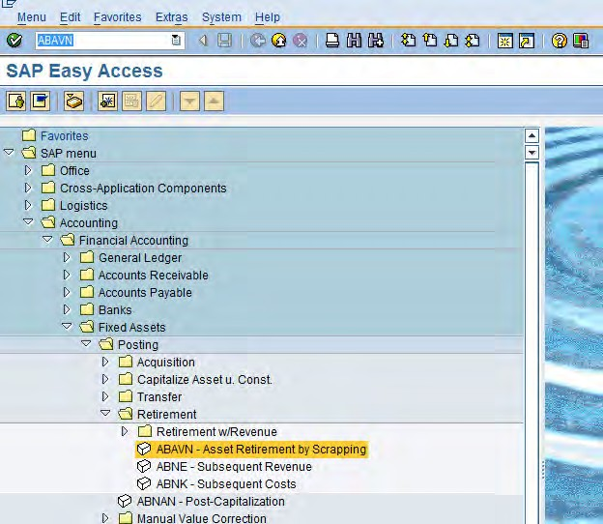

Enter the transaction code ABAVN in command text field

OR

Follow the path to Retire Asset by scrapping

1. On the Enter Asset transaction: Asset Retirement by Scrapping screen, make the following entries:

|  |  |  |  |
| --- | --- | --- | --- |
| Field name | Description | R/O/C | Values |
| Asset | Asset Number of the Retiring Asset | R | Example: 200006 − 0 |
| Document Date | Date of the Source document | R | Example: Today’s Date |
| Posting Date | Date for posting a document to financial accounting. This will determine which fiscal period (also known as  posting period) the transaction is recognized | R | Example: Today’s Date |
| Asset Val. Date | The date from which system stop depreciation. | R | Example: Today’s Date |
| Text | Contains an explanatory text line | O | Example: Asst Scrapping |

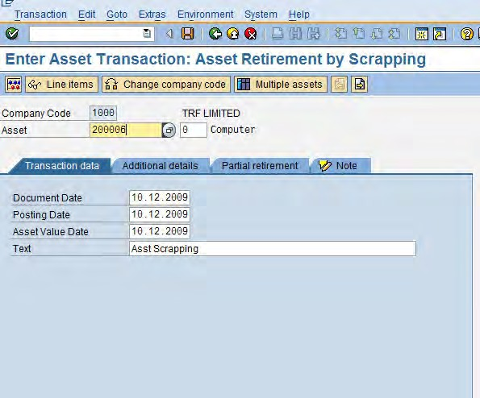

Key in the asset number or press on this input help

icon , which will list out the assets available



Note: If no depreciation area defined then the asset will not simulate. Message will be displayed at the bottom of the screen.

1. Click on the Save button or press Ctrl + S to post the document.
2. The entry will get posted
3. Click on the Exit  button or press Shift+F3 to return to the SAP Easy Access screen.

End of document – of T-code ABAVN

− Warning

 − Error  − Information



Partial Retirement

1. Follow the above procedure from point 1 to 3 and additionally
2. Click the Partial Retirement  tab and enter the Posting period, Document Type and the Transaction type

|  |  |  |  |
| --- | --- | --- | --- |
| Field name | Description | R/O/C | Values |
| Amount Posted | Amount posted per depreciation area and business  transaction | R | Example: 1500000 |
| Percentage Rate | IF YOU WANT TO POST PARTIAL RETIREMENT, ENTER THE AMOUNT OF THE ASSET BEING RETIRED AS A  PERCENTAGE HERE | R | Example: 50% |
| Quantity | Portion of the total purchase order quantity that you wish to allocate to this accounting assignment. The quantity entered determines which portion of the costs you wish to distribute to this account  assignment team | R | Example: 5 |
| Related to | The asset acquisition type | R | Example: |

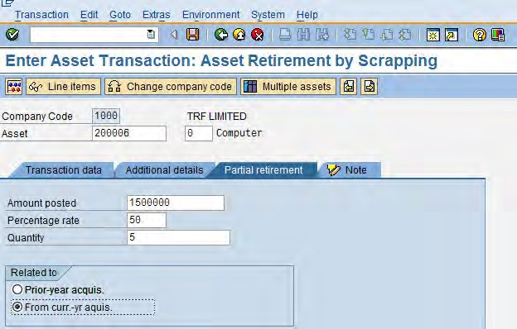

6. Click on the Save

button or press Ctrl + S to post the document.

1. The entry will get posted
2. Click on the Exit  button or press Shift+F3 to return to the SAP Easy Access screen.  The system task is complete

11. Transfer within Company Code − ABUMN

There are basically three reasons why you might need to carry out an intra−company transfer within a company code. One reason is if changes are made to organizational structures (reclassification of asset classes, changes to profit centers, and so on). Second, an intra−company transfer might be necessary if account assignments are incorrect (for example, incorrect asset class). The third reason is if a managed asset under construction is completed for summary settlement.

Intra−company transfers from one fixed asset to another within the same company code can be carried out in one step. Automatic intra−company transfers are only possible, however, if no values from the sending asset are lost and every area of the target asset is supplied with values

Use this process when the class of Asset is needed to be changed.

1. Access the transaction choosing one of the following navigation options:

|  |  |
| --- | --- |
| SAP R/3 menu | Accounting C Financial Accounting C Posting C Transfer C  ABUMN - Transfer within Company Code |
| Transaction code | ABUMN |

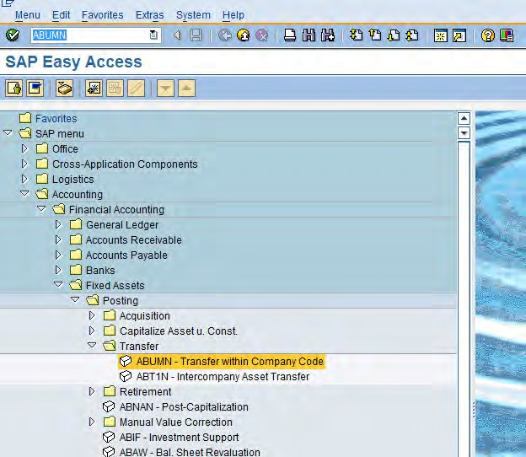

Enter the transaction code ABUMN in command text field OR

Follow the path to transfer asset within company code

1. On the Enter Asset transaction: Asset Retirement by Scrapping screen, make the following entries:

|  |  |  |  |
| --- | --- | --- | --- |
| Field name | Description | R/O/C | Values |
| Asset | Asset Number of the Retiring Asset | R | Example: 200006−0 |
| Document Date | Date of the Source document | R | Example: Today’s Date |
| Posting Date | Date for posting a document to financial accounting. This will determine which fiscal period (also known as  posting period) the transaction is recognized | R | Example: Today’s Date |
| Asset Val. Date | The date from which system stop depreciation. | R | Example: Today’s Date |
| Text | Contains an explanatory text line | O | Example: Asset Transfer |

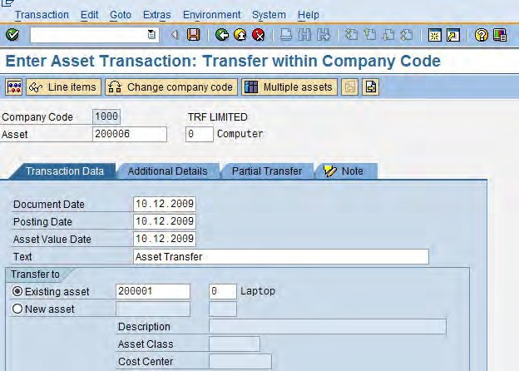

1. Click on the Save  button or press Ctrl + S to post the document.
2. The entry will get posted
3. Click on the Exit  button or press Shift+F3 to return to the SAP Easy Access screen.

End of document – of t-code ABUMN



Partial Transfer

1. Follow the above procedure from point 1 to 3 and additionally
2. Click the Partial Transfer  tab and enter the Posting period, Document Type and the Transaction type

|  |  |  |  |
| --- | --- | --- | --- |
| Field name | Description | R/O/C | Values |
| Amount Posted | Amount posted per depreciation area and business  transaction | R | Example: 1500000 |
| Percentage Rate | IF YOU WANT TO POST PARTIAL RETIREMENT, ENTER THE AMOUNT OF THE ASSET BEING RETIRED AS A  PERCENTAGE HERE | R | Example: 50% |
| Quantity | Portion of the total purchase order quantity that you wish to allocate to this accounting assignment. The quantity entered determines which portion of the costs you wish to distribute to this account  assignment team | R | Example: 5 |
| Related to | The asset acquisition type | R | Example: |

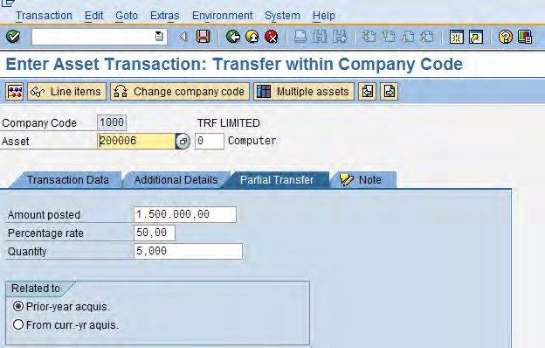

3. Click on the Save

button or press Ctrl + S to post the document.

1. The entry will get posted
2. Click on the Exit  button or press Shift+F3 to return to the SAP Easy Access screen.  The system task is complete

12. Asset under Construction: AIAB

Assets under construction (AuC) are a special form of tangible asset. They are usually displayed as a separate balance sheet item and, therefore, require separate account determination and asset classes. During the phase in which an asset is under construction, all actual postings are assigned to the AuC. Once the asset is completed, a transfer is made to a master record that has to be created in the completed fixed assets.

Assets under construction can be managed for summary settlement or by line item. In the case of summary management, the entire expenses incurred are transferred once or several times to the asset(s) in the completed tangible fixed assets at the time of completion. When assets under construction are managed by line item, you can enter settlement rules for every line item assigned to the AuC.

* 1. Access the transaction choosing one of the following navigation options:

|  |  |
| --- | --- |
| SAP menu | Accounting  Financial Accounting  Fixed Assets  Posting   Capitalize Asset u. Const.  Distribute |
| Transaction code | AIAB |

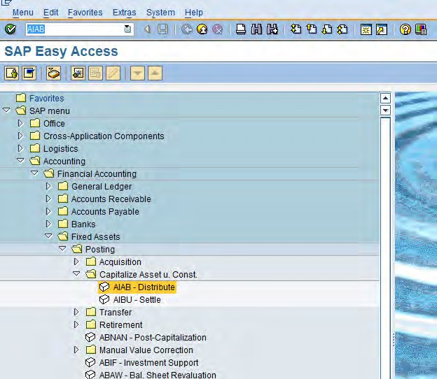

Enter the transaction code AIAB in command text field

OR

Follow the path to Distribute Assets

* 1. Enter the Company code, Asset number to be distributed

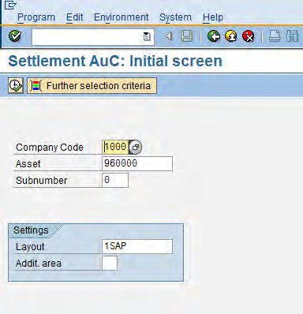

* 1. Click on Execute button

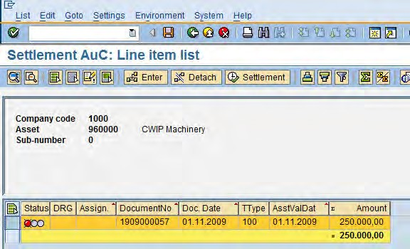

Select the line by clicking on the side of the line item and click on enter button

* 1. Click on Enter button
  2. In the following screen, enter the Category, Settlement receiver and % and press enter (please refer the below screen shot)

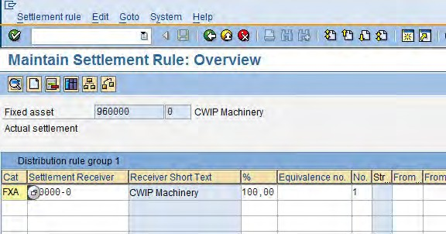

* 1. Click on Back button, the status would have changed to GREEN
  2. The system will display that the “Distribution rules saved” in the status bar

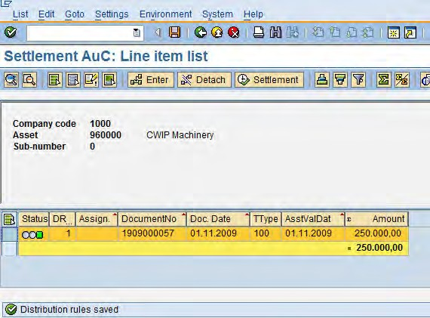

* 1. Click on the Exit  button or press Shift+F3 to return to the SAP Easy Access screen.

The system task is complete.

End of document – on T-code AIAB

13. Asset under Construction: AIBU

1. Access the transaction choosing one of the following navigation options:

|  |  |
| --- | --- |
| SAP menu | Accounting  Financial Accounting  Fixed Assets  Posting   Capitalize Asset u. Const.  AIBU – Settle |
| Transaction code | AIBU |

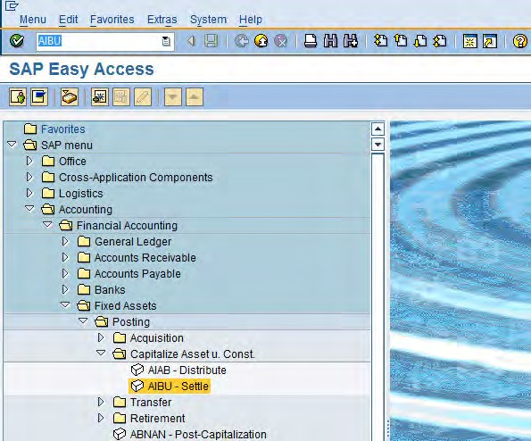

Enter the transaction code AIBU in command text field

OR

Follow the path for Settlement of Asset

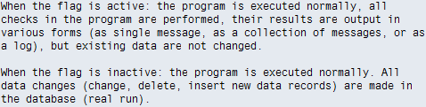

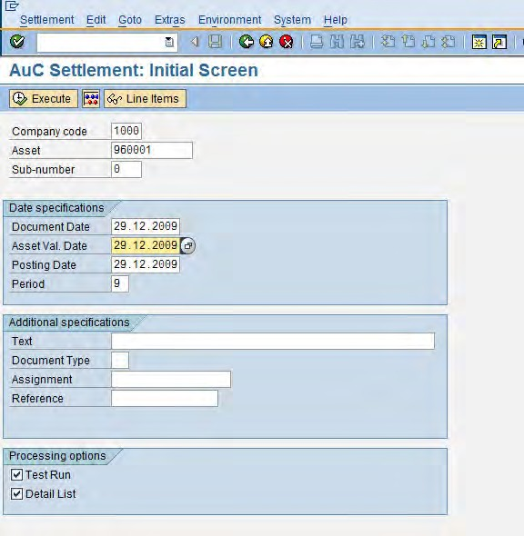

1. On screen “AuC Settlment: Initial Screen” enter information in the fields as specified in the table below

|  |  |  |  |
| --- | --- | --- | --- |
| Field Name | Description | R/O/C | Values |
| Company  Code | Enter your Company Code | R | Example: 1000 |
| Asset | Enter the asset to be settled | R | Example: 960001 |
| Sub−  number | Enter the sub asset number | O | Example: 0 |
| Document  date | Date on which the original document was issued | R | Example: 29.12.2009 |
| Asset Val.  Date | Value date of asset, it can be other than the posting and  document date. | R | Example: 29.12.2009 |
| Posting  Date | Date of entry | R | Example: 29.12.2009 |
| Period | This is automatically populated, the user can update it as per  TRF requirement | R | Example: 9 |
| Test Run | If this check box is selected the program will run in TEST MODE.  Make sure to mark the indicator on before actual run | R | Example: |

Note:

1. Click on Execute button

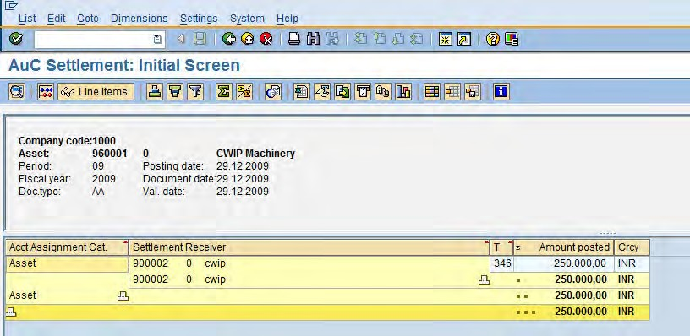

1. Verify the details and click on Back button

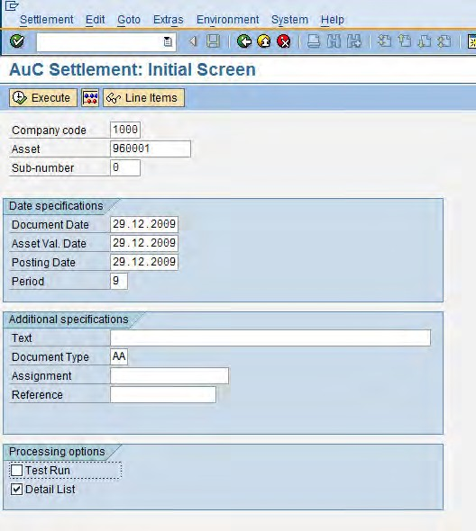

* 1. Now, uncheck Test run check box and click on Execute button

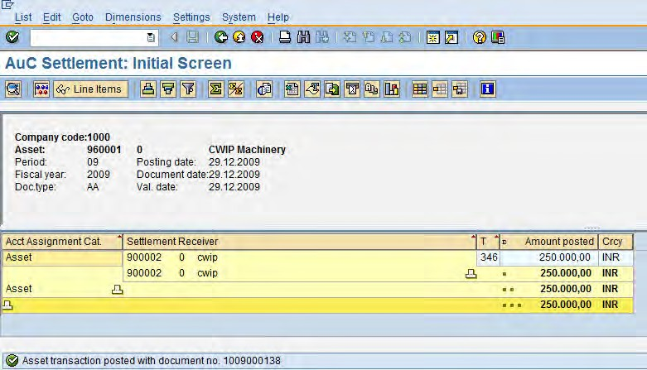

* 1. The system will display that the “Asset transaction posted with document no. 1009000138” in the status bar
  2. Click on the Exit  button or press Shift+F3 to return to the SAP Easy Access screen.

 The system task is complete.

End of document – on T-code AIBU

14. Fixed Asset Register − S_ALR_87011963

The report displays the values of all assets in a depreciation area. The following values are displayed in detail per asset:

* The cumulative acquisition value at the beginning of the fiscal year
* Accumulated depreciation, including the planned depreciation for the current fiscal year (the sum of all depreciation types)
* The planned book value at the end of the reporting year

Additional standard versions of the report allow for primary selection and creation of totals according to various criteria (asset class, business area, cost center, and so on).

1. Access the transaction choosing one of the following navigation options:

|  |  |
| --- | --- |
| SAP R/3 menu | Accounting C Financial Accounting C Fixed assets C Information System  🡪 Reports on asset Accounting 🡪 Asset Balances 🡪 Balance List 🡪  Asset Balances 🡪 S_ALR_87011963 |
| Transaction code | S_ALR_87011963 |

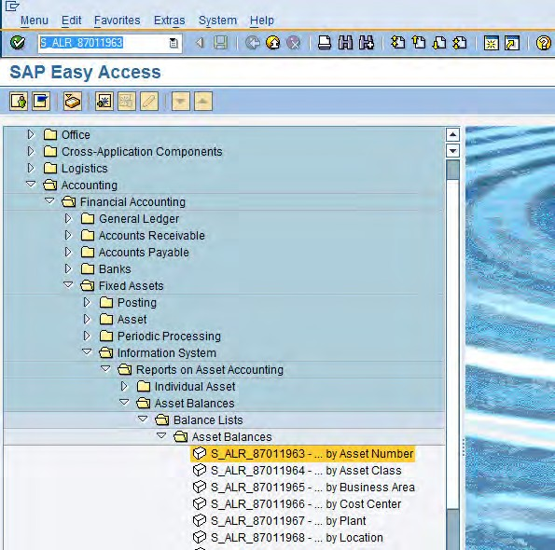

Enter the transaction code S_ALR_87011963 in command text field OR

Follow the path to View the fixed asset register

1. Update the following required and optional fields

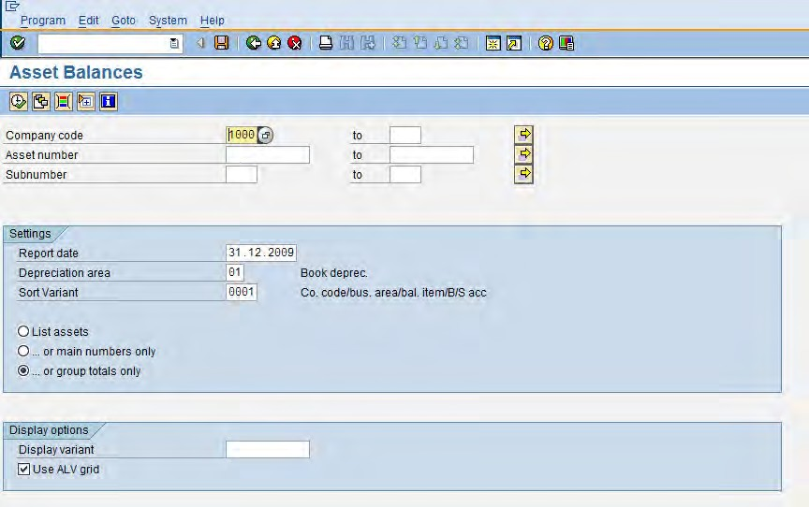

Here the user can update the asset number or provide number range if available

1. Click on Execute button, the following Asset Balances screen will be displayed. The user can verify the details from this screen

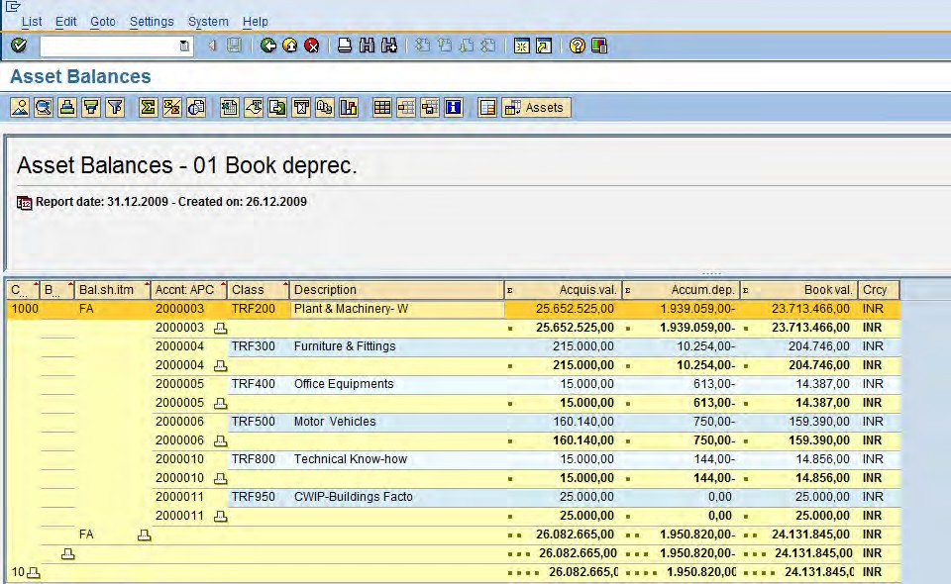

Acquisition value of the asset

Accumulated Depreciation

Book value of the asset

1. Select a line item and double click to view details of the asset



1. The below screen will be displayed with the details of the particular asset selected

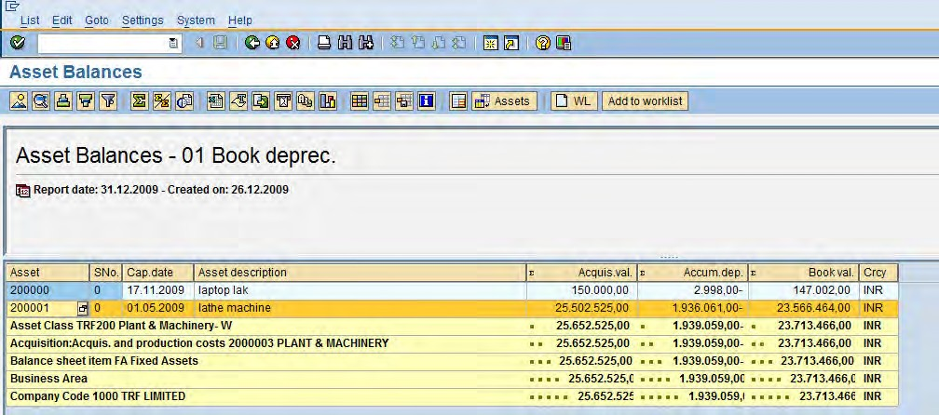

1. Select a line item and double click to view further details of the asset (drill down)

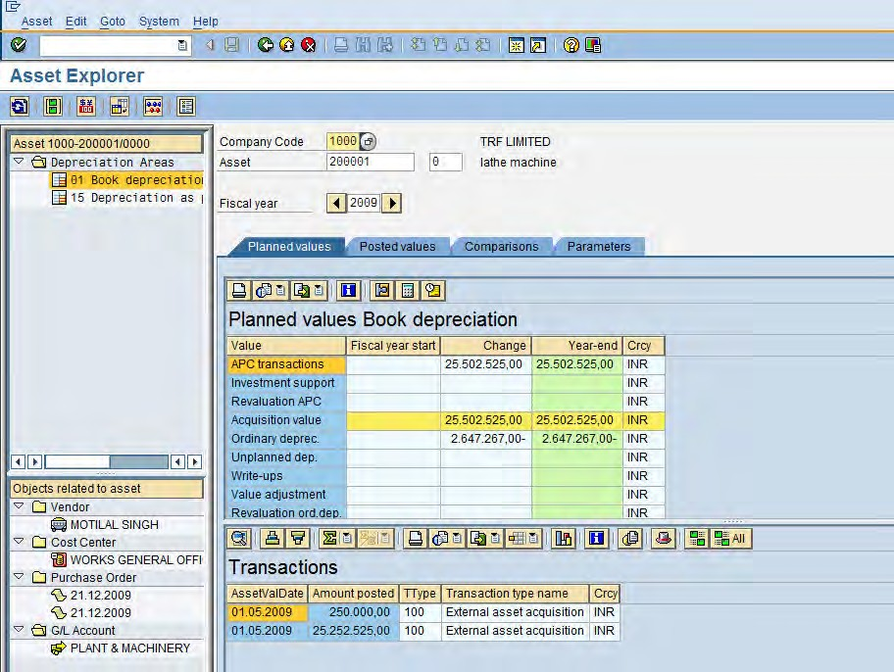

The user can download the details in form of report, follow the below instructions

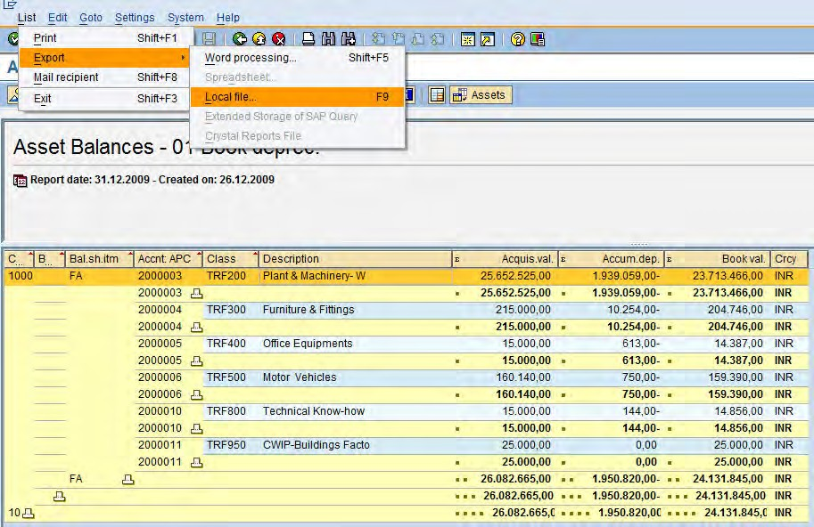

1. In the following pop up window

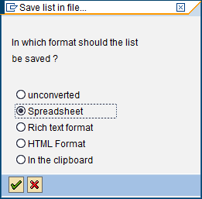

1. Select the Spreadsheet radio button

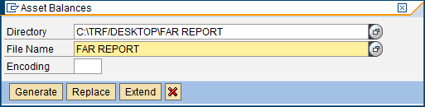

1. Click on generate button, the file will be downloaded at the directory path given by the user
2. Click on the Exit  button or press Shift+F3 to return to the SAP Easy Access screen.

The system task is complete.



End of document – of T-code S_ALR_87011963

15. General Icons across SAP

|  |  |
| --- | --- |
| Icons | Description |
|  | Enter |
|  | Back (F3) |
|  | Continue (Enter) |
|  | Cancel (F12) |
|  | Post (Ctrl + S) |
|  | Select All |
|  | Log off or Exit |
|  | Cancel |
|  | Drop down list |
|  | All Selections (Shift + F7) |
|  | Creates a new session |
|  | Generates a shortcut |
|  | Help (F1) |
|  | Customizing of Local Layout (Alt + F12) |
|  | Display Previous Item (Shift + F6) |
|  | Display Next Item (Shift + F7) |
|  | Print (Ctrl + P) |
|  | Find (Ctrl + F) |
|  | Find Next (Ctrl + G) |
|  | First Page (Ctrl + Page up) |
|  | Previous Page |
|  | Next Page |
|  | Last Page (Ctrl + Page down) |
|  | Drop down list (F4) |
|  | Simulate |
|  | Execute (F8) |
|  | Technical Information (Ctrl + Shift + F7) |

|  |  |
| --- | --- |
|  | Message Long Text (Ctrl + Shift + F6) |
|  | Terminations (Shift + F4) |
|  | Filter |
|  | Set in Ascending Order |
|  | Set in Descending Order |
|  | Caution |
|  | Example |
|  | Note |
|  | Recommendation |
|  | Syntax |
|  | External process |
|  | Business Process Alternative/Decision Choice |

